- The case of Isaac:

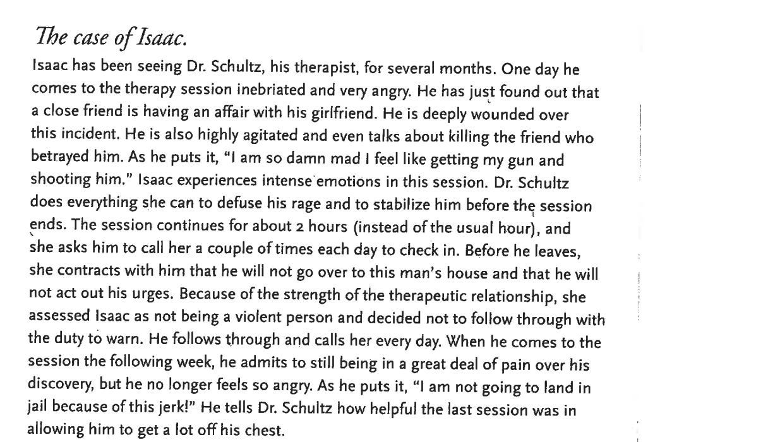

-What are the ethical and legal issues in this case?
-Did Dr. Schulz follow proper ethical and legal responsibilities?

-What criteria would you use to determine whether the situation is dangerous enough to warn the potential victim?

-What steps would you suggest Dr. Schulz take?

- The case of Vijay.

Vijay, a 16-year-old, is being seen by a counselor, Roshawn, at the request of his parents. Vijay's schoolwork has dropped off, he has become withdrawn socially, and he has expressed to his parents that he has thought of suicide, even though he has not made a specific plan. After the counselor has seen Vijay for several weeks of individual counseling, his concerned parents call and ask how he is doing. They wonder whether they should be alert to possible suicide attempts. Vijay's parents tell Roshawn that they want to respect confidentiality and are not interested in detailed disclosures but that they want to find out if they have cause for worry. Without going into detail, Roshawn reassures them that they really do not need to worry.

Did Roshawn have sufficient information to justify telling the parents that they have no need to worry?
  - Is Roshawn's behavior ethical? Would it make a difference if Vijay were 25 years old?
  - Does Roshawn have an ethical obligation to inform Vijay of the conversation with his parents?
  - If the parents were to insist on having more information, does Roshawn have an obligation to say more?
  - If Vijay were suicidal, what ethical and legal obligations would Roshawn have toward the parents?

Corey, G., Corey, M., Corey, C., and Callanan, P. (2015). Issues and Ethics in the Helping Profession. Stamford, CT: Cengage Learning. pp. 211-246.

- The case of Emmanuel.

Emmanuel is a middle-aged widower who complains of emptiness in life, loneliness, depression, and a loss of the will to live. He has been in individual therapy for 7 months with a counselor. Using psycho-diagnostic procedures, she has determined that Emmanuel has serious depressive tendencies and is potentially self-destructive. In their sessions he talks about the history of his failures, the isolation he feels, the meaninglessness of his life, and his feelings of worthlessness and depression. With her encouragement he experiments with new ways of behaving in the hope that he will find reasons to go on living. Finally, after 7 months of searching, he decides that he wants to take his own life. He tells his counselor that he is convinced he has been deluding himself in thinking that anything in his life will change for the better and that he feels good about deciding to end his life. He informs her that he will not be seeing her again. The counselor expresses her concern that Emmanuel is very capable of taking his life. She acknowledges that the decision to end his life by suicide is not a sudden one, but she lets him know that she wants him to give therapy more of a chance. He says that he is truly grateful to her for helping him. He says firmly that he does not want her to attempt to obstruct his plans in any way. She asks that he postpone his decision for a week and return to discuss the matter more fully. He tells her he isn't certain whether he will keep this appointment, but he agrees to consider it.

- What do you think of the way the counselor dealt with her client?

- What would you have done differently if you had been Emmanuel's counselor? How would your viewpoint regarding suicide influence your approach with Emmanuel?

- What personal values or issues of your own would be triggered by this case? Which of the following actions might you have pursued?

- Committed him to a state hospital for observation, even against his will, for 72 hours
- Consulted with another professional as soon as he began to discuss suicide as an option
- Respected his choice of suicide, even if you did not agree with it
- Informed the police and reported the seriousness of his threat.

Corey, G., Corey, M., Corey, C., and Callanan, P. (2015). Issues and Ethics in the Helping Profession. Stamford, CT: Cengage Learning. pp. 211-246.

- The case of Martina.

Martina, a counselor, has reason to believe that her 14-year-old client is being physically abused. As part of the abuse, critical medication is being withheld. Martina reports the incident to Child Protective Services and gives all the information she has to the caseworker. She follows up the phone conversation with the caseworker with a written report. A week later, the client tells her that nothing has been done.

- Has Martina adequately fulfilled her responsibility by making the report? Does she have a responsibility to report the agency for not having taken action?

- If the agency does not take appropriate action, does Martina have a responsibility to take other measures? Are there opportunities to empower the client to get the medication she needs?

- From whom would you seek consultation? What referrals would be important to consider?

• Would it be ethical for Martina to take matters into her own hands and to call for a family session or make a house call, especially if the client requests it?

Corey, G., Corey, M., Corey, C., and Callanan, P. (2015). Issues and Ethics in the Helping Profession. Stamford, CT: Cengage Learning. p. 211-246.

- The case of Lorenzo.

Lorenzo, 16 years old, is sent to a family guidance clinic by his parents. During the first session the counselor sees Lorenzo and his parents together. She tells the parents
in his presence that what she and Lorenzo discuss will be confidential and that she
will not disclose information acquired through the sessions without his permission.
The parents seem to understand that confidentiality is necessary for trust to develop between their son and his counselor.
At first Lorenzo is reluctant to come in for counseling. Eventually, as the sessions go on, he discloses that he has a serious drug problem. Lorenzo's parents know that he was using drugs at one time, but he has told them that he is no longer using them. The counselor listens to anecdote after anecdote about Lorenzo's use of illegal drugs, about how "I am loaded at school every day," and about a few brushes with death when he was under the influence of illegal substances. Finally, she tells Lorenzo that she does not want the responsibility of knowing he is experimenting with illegal drugs and that she will not agree to continue the counseling relationship unless he stops using them. At this stage she agrees not to inform his parents, on the condition that he quits using drugs.

- What is your general impression of the way Lorenzo's counselor handled the case?
- Do you think the counselor acted in a responsible way toward the client? the parents?
- If you were convinced that Lorenzo was likely to hurt himself or others because of his drug use and his emotional instability, would you have informed his parents, even at the risk of losing Lorenzo as a client? Why or why not?

Corey, G., Corey, M., Corey, C., and Callanan, P. (2015). Issues and Ethics in the Helping Profession. Stamford, CT: engage Learning. pp. 211-246.

- Case of Hope by Chris C. Lauer in Herlihy & Corey, 2015

Hope, a 28-year-old single African American woman, attends weekly therapy sessions in New Orleans. Hope is HIV positive, in good health, and compliant with her medications for HIV and depression. Hope has a 4-year-old daughter named Angela.

Hope proactively sought an HIV test 4 years ago in response to a public service campaign. Shortly after she learned of her status, she sought medical help. Six months ago, during a medical appointment with her doctor, Hope appeared anxious and possibly depressed. At the recommendation of her doctor, Hope agreed to speak with one of the on-staff psychiatrists.

The psychiatrist administered the Beck Depression Inventory (Beck, Steer, & Brown, 1996) and the Beck Anxiety Inventory (Beck & Steer, 1990); Hope's scores indicated both moderate depression and moderate anxiety. After discussing these results with the psychiatrist, Hope decided that she would begin taking an antidepressant and would see a counselor. The psychiatrist prescribed an inexpensive antidepressant and asked to see her in 3 weeks.

Presently, Hope is seeing Patrick, a counselor at NATF. She has been attending counseling weekly for 5 months. Her presenting issue was that she feels entrapped by her circumstances. Hope lives in a newer subsidized housing development. She reports that she does not feel connected to the neighborhood and its residents because her family, with the exception of her aunt, chose to remain in Chicago after Hurricane Katrina. Before the storm, she socialized with her neighbors, but Hidden Oaks' covenants do not allow people to congregate on their front porches. Hope feels torn, unable to figure out how to care for her daughter, maintain her $10 per hour job at a small hotel, and manage her health. Hope wants more but sees little opportunity to improve her life given her income, lack of a high school diploma, HIV status, and being a single mom.

Hope loves her daughter, Angela, and appears to cater to her physical and emotional needs as best she can. Hope also likes to have fun and has reported “living it up,” drinking and smoking pot, on occasion, at her local bar. Today is the third time in 5 months that Hope has brought Angela to her counseling session because neither her aunt nor a neighbor could sit with Angela. During the session Angela begins to whine. Hope stands up, walks over to Angela, and slaps her. The slap isn't overly hard, but neither is it soft. Angela begins to cry.

Questions
- Identify the ethical concerns in this case. Does the slap constitute child abuse?
- Which steps would you take to ensure you are responding ethically to each of these identified concerns.
- Is disclosure required at this point? If disclosure becomes necessary what are the potential consequences to the counseling relationship? What are the potential consequences for Hope and Angela?
- How might culture and life circumstances come into play in this situation?

- Case of Nicole, by Amanda Crawford in Herlihy & Corey, (2015)

Nicole works as community treatment counselor. This program provides mental health services in rural communities. Nicole, the counselor, works with children who have been identified as suffering from a serious emotional disturbance. This program functions similarly to an outpatient facility, yet it is housed in the school.

Nicole began working with a 12 year old, Lauren, and her aunt, Maria. At the initial consultation with Maria, with whom Lauren lives full time, Nicole was informed of Lauren's recent risky behavior both at home and in school. Lauren was struggling in school and at home as evidenced by loss of temper, arguments with adults, compulsive lying, withdrawal from her adult relationships, missing curfew, blaming, anger, and spiteful behavior.

Nicole met regularly with Lauren in individual, group, and family therapy sessions for 8 weeks. During this time rapport was built between Lauren and Nicole. Lauren disclosed information about relationship struggles, feelings underlying her recent withdrawal from adult relationships, and her current struggles with her sexual orientation. During an individual therapy session 8 weeks after Lauren began counseling, Lauren asked for clarification of confidentiality and then shared that she is sexually attracted to females and is in an experimental relationship with an older 14-year-old girl.

Soon after Lauren's disclosure of her sexual orientation and discussion about her sexual experimenting, Maria came to the office for a treatment plan update meeting. Maria wanted to know how to best support her niece. She is open to being more involved with sessions and would like to be a part of the treatment plan. Lauren has expressed a desire to have a space where she can discuss feelings and where her revelations will not be shared with her aunt.

- Identify the ethical and legal issues in this case. What steps would you take?
- Would you advise Lauren to disclose anything to her aunt? Would you involve the Aunt in any way in treatment? What are the potential consequences to the counseling relationship? What are the potential consequences for Lauren and Maria?
- How would you respond to Maria?

- The case of Marcie. (Pearson Education, Inc, 2025)

Marcie is a new client, a 22-year-old female who works as a receptionist in a doctor’s office.
She has just revealed to you, during the intake session, that she has recently lost interest in most activities, has been experiencing fatigue despite sleeping a great deal, and sometimes wishes she could cease to exist. She mentioned feeling as though she were “on an emotional roller coaster” during the past year, throughout her on-again, off-again relationship with a 35-year-old married man. The last breakup with him seemed really final, and Marcie has felt herself sinking deeper and deeper ever since. When probed further about suicidal ideations, Marcie admitted that she has considered killing herself, although she is uncertain whether or not she would actually do it. She said that she is currently in possession of a gun that her friend allowed her to keep in her home, following a rash of burglaries in the neighborhood, but she doesn’t know whether she would actually use it. You have consulted with your supervisor, who has agreed that Marcie should be referred immediately for a psychiatric evaluation and has instructed you to arrange for Marcie to go directly from your office to a nearby hospital. Marcie told you that her mother accompanied her to this appointment and is in the waiting room, but she has emphatically stated that she does not want her mother to know what is going on with her.
-What are the ethical and legal responsibilities in this case?
-How should this sensitive situation be handled in light of Marcie’s wishes regarding her mother?
-What steps would you take?

